
How To Measure Your Ring Size
Read These Tips First
You will want the ring to fit snug, but not too tight – the ring needs to be able to slide over your knuckle so you can get it on and off your finger. We recommend measuring multiple times for accuracy.
Also, keep in mind that your fingers can change size for various reasons. For example, did you know it is best to measure your fingers at the end of the day? That’s because they are warm and truer to size, instead of the early morning when your fingers are colder and at their smallest. Your finger size can also be impacted by:
- Water retention
- Weight gain/loss
- Health issues (like high blood pressure)
- Pregnancy
And here’s an interesting fact you may not realize - the ring size of a person’s dominate hand may be up to a half size larger than their non-dominate hand.
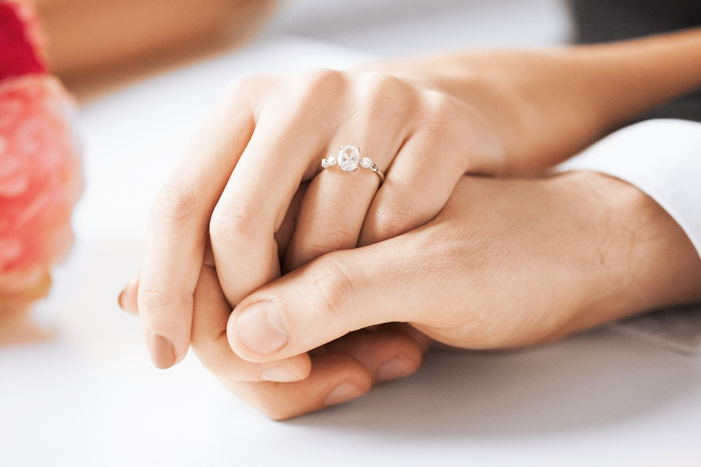

Now Follow These Simple Steps:
Step 1: Gather string, scissors, marker and a ruler.
Step 2: Cut a piece of string long enough to wrap around your finger.
Step 3: Wrap the string around the base of your knuckle and mark the string where it meets on your finger with the marker.
Step 4: Place the string along your ruler and note the length. If you are using an inch ruler convert the size to millimeters using this easy online converter. This will give you the circumference in millimeters.
Step 5: Refer to the chart below to see what your ring size is:
Millimeters | Ring Size | Millimeters | Ring Size
44.2 | 3 | 58.3 | 8.5
44.8 | 3.25 | 58.9 | 8.75
45.5 | 3.5 | 59.5 | 9
46.1 | 3.75 | 60.2 | 9.25
46.8 | 4 | 60.8 | 9.5
47.4 | 4.25 | 61.4 | 9.75
48.0 | 4.5 | 62.1 | 10
48.7 | 4.75 | 62.7 | 10.25
49.3 | 5 | 63.4 | 10.5
50.0 | 5.25 | 64.0 | 10.75
50.6 | 5.5 | 64.6 | 11
51.2 | 5.75 | 65.3 | 11.25
51.9 | 6 | 65.9 | 11.5
52.5 | 6.25 | 66.6 | 11.75
53.1 | 6.5 | 67.2 | 12
53.8 | 6.75 | 67.8 | 12.25
54.4 | 7 | 68.5 | 12.5
55.1 | 7.25 | 69.1 | 12.75
55.7 | 7.5 | 69.7 | 13
56.3 | 7.75 | 70.4 | 13.25
57.0 | 8 | 71.0 | 13.5
57.6 | 8.25 | 72.3 | 14
